Linux Basic Assignment-Nilay Budhe
1. Creating and Renaming Files/Directories
- Create a directory named test_dir using mkdir.
Explanation : Currently I am in root directory, I have created test_dir folder using mkdir command. Ls command to check folder present in directory.
- Inside test_dir, create an empty file called example.txt.
Explaination : test_dir folder created in last question, now I inserted in test_dir folder and create empty text file using touch command.
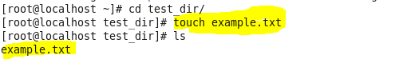
- Rename example.txt to renamed_example.txt using mv
Explaination: Now I’m in test_dir folder , empty text file was created and now renaming as renamed_example.txt using mv command.
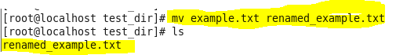

2. Viewing File Contents
2.1 Use cat to display the contents of /etc/passwd.
Explanation : all information are displayed, which is in passwd file.
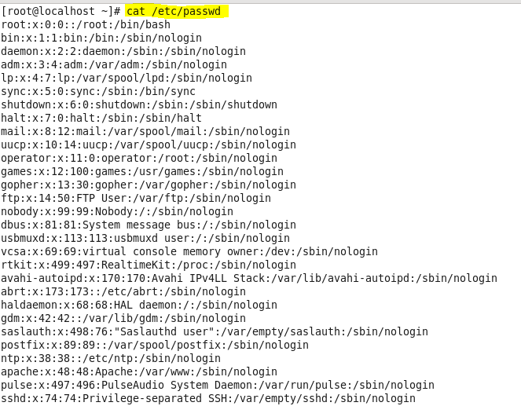
2.2 Display only the first 5 lines of /etc/passwd using head.
Explanation : top (first) 5 lines display using head command. - n is no.of lines
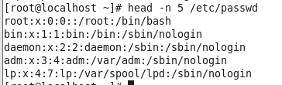
2.3 Display only the last 5 lines of /etc/passwd using tail.
Explanation : last 5 lines displayed usomg tail command
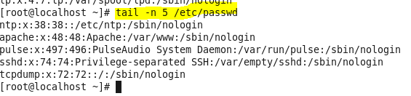

3.Searching for Patterns
3.1 Use grep to find all lines containing the word "root" in /etc/passwd.
Explanation: when we search root word in passwd file, two line found which contains root.
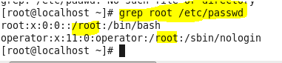
4. Zipping and Unzipping
4.1 Compress the test_dir directory into a file named test_dir.zip using zip.
Explanation: we have zip the folder test_dir , which reduces the size. Currently no more size of file in folder so size reduction not seem.
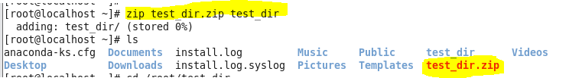
4.2 Unzip test_dir.zip into a new directory named unzipped_dir.
Explanation : now unzip the test_dir.zip folder and extract into new folder unzipped_dir.
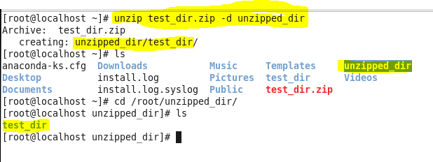

5. Downloading Files
5.1 Use wget to download a file from a URL (e.g., https://example.com/sample.txt).
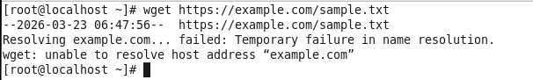
6. Changing Permissions
6.1 Create a file named secure.txt and change its permissions to read-only for everyone using chmod.
Explanation : first created secure.txt text file and apply readonly permission.
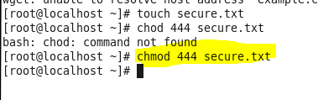

7. Working with Environment Variables
Use export to set a new environment variable called MY_VAR with the value "Hello, Linux!".
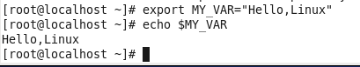

Submission Guidelines -: Attach Screenshots or command along with explanation and submit in doc(google doc or microsoft doc) format also attach github repo link

